Stock transaction (java) Project pictures

Total images: 01

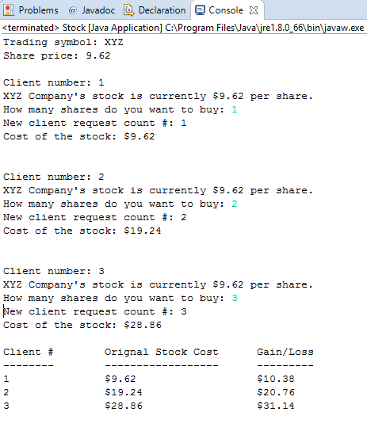

Fig 1: Stock transaction program